Vuelo Químico (MFP 1307)

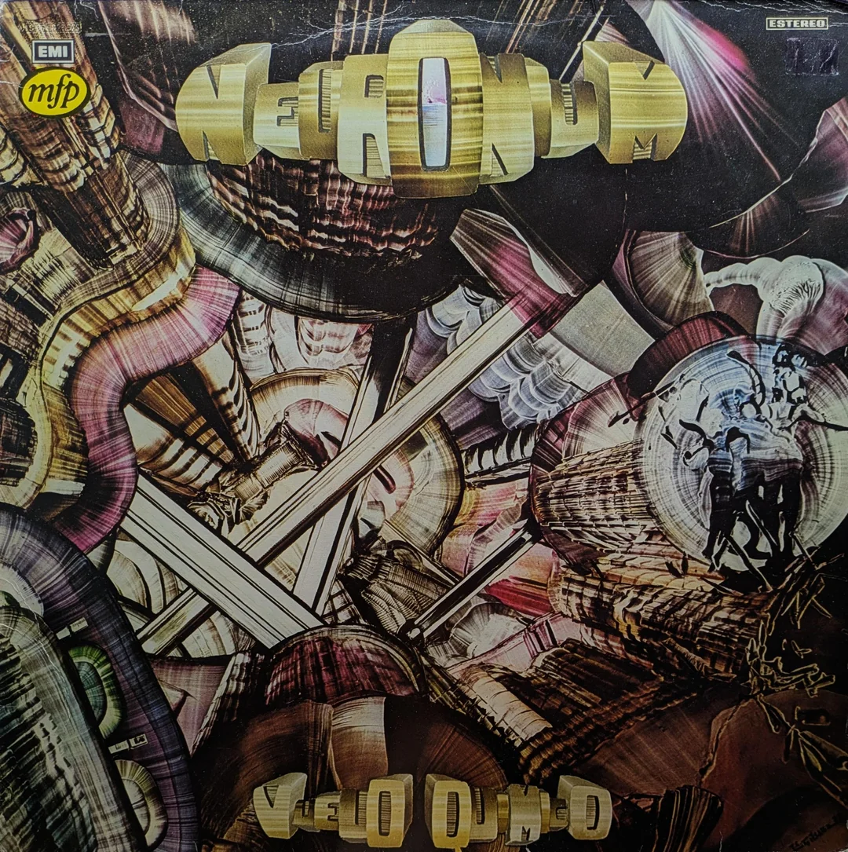
Originally released on Harvest this has to be one of the more eccentric MFP releases.

This is Neuronium’s second lp in the unusual world of Spanish 'cosmic music'. Michael Huygen was the founding member and driving force. The style, psychotronic music, was more about generating relaxation and imaginative states through floating, textured synthesis. This is not a pastiche of Kraftwerk or Vangelis – it is closest in style to psychedelic or progressive rock but using the tools of synthesis, and with very little percussion.

The album is dedicated to the poet Edgar Allan Poe. It also features a special guest appearance from Velvet Underground singer Nico, who vocalises some of his poetry. Her appearance, in a way, adds heft to the aim of altering states of mind with vocals that feel very other worldly. According to her biographer, Jeniffer Bickerdike:

The collaboration came about by chance: she happened to be in the same recording studio during the sessions and was reportedly so moved by the music that she asked if she could take part.

It is a really cool record and a really relaxing album to just dip in and out of. A record that slips between genre cracks, not being a prog record or fully electronic. And it is not part of a wider movement, just out on its own.

Perhaps the reason for the MFP reissue was down to the Nico connection? There are not to my knowledge any similar releases on the label.

